Comparative Analysis of Crude Oil and Natural Gas Prices Using Data Analytics and Technical Indicators (2023 – Feb 2026)

Project Overview
This project analyses the historical price behaviour of Crude Oil and Natural Gas from 2023 to 15 February 2026 using Python, SQL, and Power BI. The study combines data analytics, technical indicators, and real-world global events to understand price movements, volatility, and market trends in the energy sector.
The project aims to demonstrate how data-driven insights, when combined with macroeconomic and geopolitical news, can support informed decision-making for traders, analysts, and business stakeholders.

Business Problem Statement
Energy commodity prices are highly volatile due to:
- Geopolitical conflicts
- Supply–demand imbalances
- Weather conditions
- Economic cycles

Understanding why prices move, not just how they move, is critical for:
- Risk management
- Trading strategies
- Energy sector planning

This project bridges technical analysis with global news events to explain price behaviour logically.

Objective
- Analyse historical price trends of crude oil and natural gas
- Measure volatility and risk using statistical methods
- Identify market trends using technical indicators (MA, RSI, MACD)
- Detect major trend reversals (Golden Cross & Death Cross)
- Link price movements with real global events and news
- To perform structured analysis using SQL queries.

- To visualize insights using Power BI dashboards.

History of Crude Oil and Natural Gas

Crude Oil
- Crude oil has been a primary source of energy since the 19th century.
- It is widely used in transportation, power generation, and the petrochemical industry.
- The price of crude oil is influenced by production levels, geopolitical conflicts,
- decisions made by oil-producing countries, and global economic conditions.

Natural Gas
- Natural gas is considered a cleaner fossil fuel compared to crude oil.
- It is mainly used for electricity generation, cooking, and industrial purposes.
- Natural gas prices are highly sensitive to seasonal demand, weather conditions, and supply disruptions.

Dataset Description

Data Source: Yahoo Finance
• Crude Oil ticker: CL=F
• Natural Gas ticker: NG=F

Time Period: February 2023 – 15 February 2026 (3 Years)

Frequency: Daily

Column Details
Column Name | Description
Date | Trading date of the commodity price
Open | Price at the beginning of the trading day
High | Highest price recorded during the trading day
Low | Lowest price recorded during the trading day
Close | Price at the end of the trading day
Volume | Total number of contracts traded on that day
Commodity | Type of commodity (Crude Oil / Natural Gas)

Tools & Technologies Used
- Python: Pandas, NumPy, Matplotlib, y finance
- Database: MySQL
- Visualization: Power BI
- Storage Format: CSV
- Indicators: RSI, MACD, Moving Averages, Volatility Metrics
Data Collection Methodology
Tool Used
- Python (y finance, pandas, numpy)
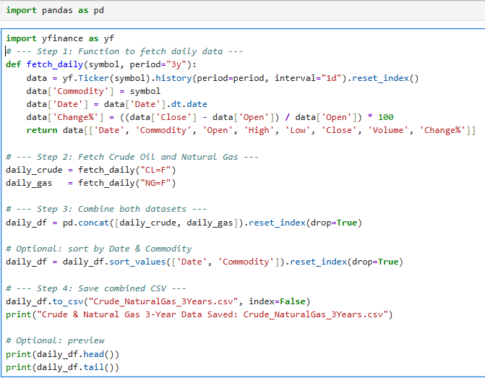
Explanation
This script automates the collection and preparation of historical daily data for crude oil and natural gas over a 3-year period.
Data Fetching:
- Uses the y finance library to download daily open, high, low, close, and volume data.
- Adds a calculated column for daily percentage change to measure price movement.
Data Structuring:
  - Each dataset is tagged with its commodity name (Crude Oil or Natural Gas).
  - Dates are standardized for consistency.

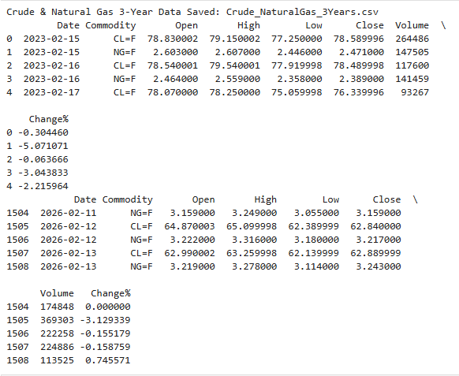

Data Management:
- The combined dataset is sorted by date and commodity.
- Saved as a CSV file (Crude_NaturalGas_3Years.csv) for future analysis.
- Preview commands (head and tail) allow quick inspection of the dataset.
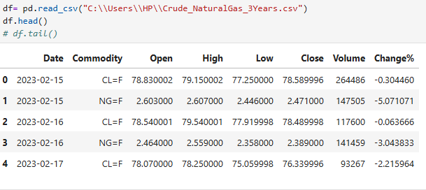

Info
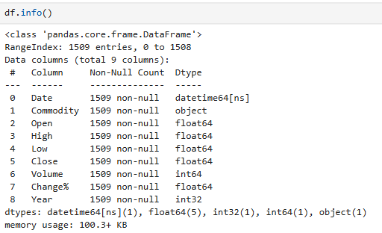
Describe
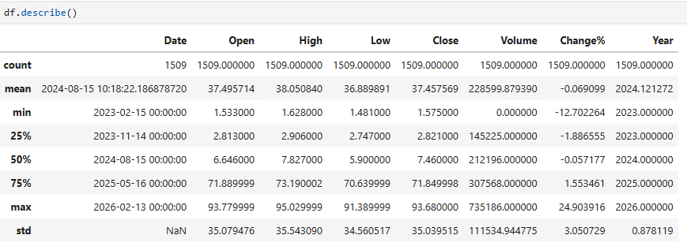
Preprocessing steps
Convert Data Types:
- Convert dates to datetime format.
- Extract year for year-wise analysis.
- To maintain data integrity and avoid errors in analysis
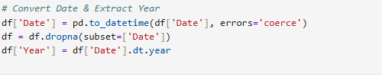
.
Filter
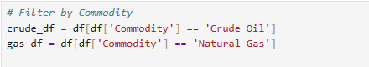
To separate the dataset into two subsets for focused analysis of each commodity.

Numeric
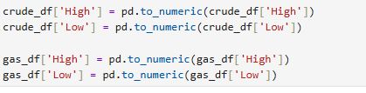
To ensure the values can be used in mathematical operations and statistical analysis.

Replace ticker symbol
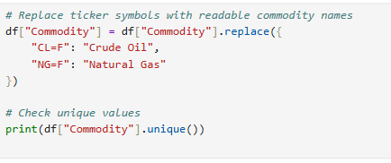
Ticker symbols like "CL=F" and "NG=F" are technical identifiers.
Readable names improve communication of insights to non-technical audiences.
To separate crude oil and natural gas data for independent analysis
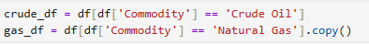
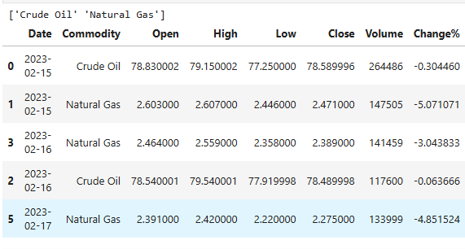

Major Global Events Impacting Prices (News-Linked)
Crude Oil Market Events

2023
- Russia–Ukraine war continued, disrupting global oil supply routes and increasing uncertainty.
- OPEC+ announced production cuts, pushing crude prices upward.
- High inflation and aggressive interest rate hikes slowed global demand.
Impact: Increased volatility and frequent price spikes.

2024
- Rising Middle East geopolitical tensions increased supply risk premiums.
- Fluctuations in US crude inventories caused short-term volatility.
- Global economic slowdown reduced industrial demand.
Impact: Prices fluctuated within a wide range, reflected in rolling volatility.

2025
- Continued supply control by oil-producing nations.
- Rapid growth in renewable energy raised long-term demand concerns.
- Crude prices showed frequent ups and downs, signalling uncertainty.
Impact: Mixed trends and repeated Golden/Death Cross signals.
2026 (Till Feb 15)
- Balanced global supply and demand led to price stabilisation.
- Early signs of economic recovery supported short-term bullish momentum.
Impact: RSI and MACD showed momentum shift and potential reversals.

Natural Gas Market Events
2023
- Europe faced an energy crisis due to reduced Russian gas exports.
- LNG demand surged, creating high volatility.
- Winter demand caused price spikes.
Impact: RSI overbought signals and volatility spikes.

2024
- Mild winter reduced heating demand.
- Increased US shale gas production lowered prices.
Impact: Lower volatility compared to crude oil.

2025
- Expansion of LNG exports increased global exposure.
- Prices became unstable with sharp spikes.
Impact: Sudden volatility bursts despite overall stability.

2026 (Till Feb 15)
- Extreme price spikes occurred, including a historical peak in January 2026.
- RSI and MACD indicated overbought and bearish conditions.
Impact: High-risk market conditions and instability.

Exploratory Data Analysis (EDA)
Daily Price Range
Purpose:
This dataset records the daily price range (difference between high and low prices) for crude oil and natural gas. It helps analysts measure short-term volatility and understand how much prices fluctuate within a single trading day.

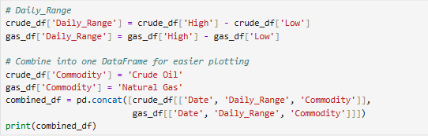
Output:
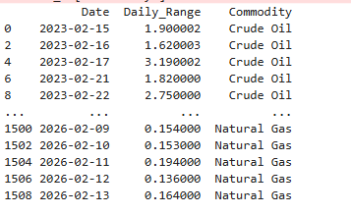

Explanation
Crude Oil (Feb 2023):
  - Daily ranges vary between ~1.6 and ~3.2 USD.
  - Larger ranges (e.g., 3.19 USD) indicate strong intraday volatility.
  - Smaller ranges (e.g., 1.62 USD) suggest calmer trading sessions.
Natural Gas (Feb 2026):
- Daily ranges are much smaller, between ~0.13 and ~0.19 USD.
- This shows natural gas is relatively stable compared to crude oil.

Year-wise Volatility
Purpose:
To calculate the annual volatility of each commodity (Crude Oil and Natural Gas) and compare their risk levels across years.
Formula:
- Volatility Year=std (Price Change of all days in that year)
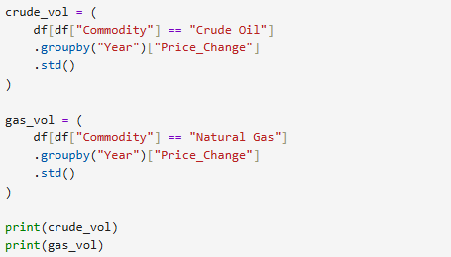

Output:
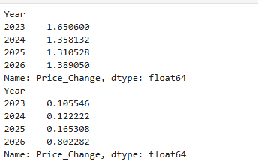

Explanation:
- Crude Oil: 2023 → 1.65, 2024 → 1.36 (higher value → more volatility in that year).
- Natural Gas: 2023 → 0.105, 2026 → 0.802 (sudden spike in 2026 indicates high risk or unusual price movement).
Matplot
Purpose:
The chart compares the volatility of crude oil and natural gas prices across the years 2023 to 2026. Volatility measures how much prices fluctuate, helping analysts assess risk and stability in each commodity.
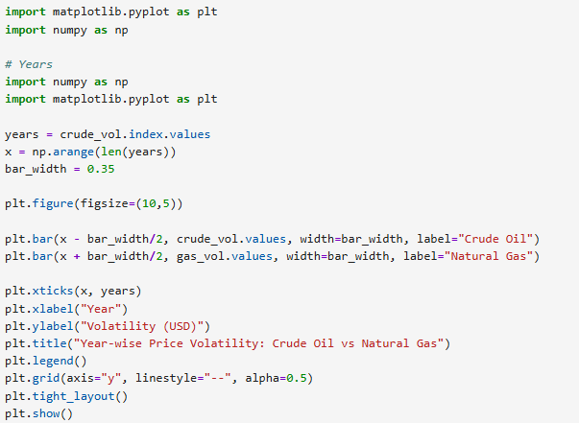
Output:
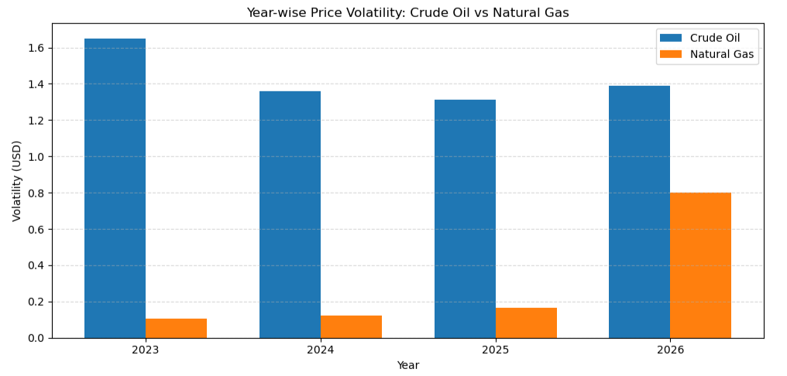
Explanation:
- Crude Oil (Blue Bars)
  - Volatility remains moderately stable, ranging between approximately 1.4 to 1.6 USD.
  - Indicates consistent but noticeable price fluctuations year-to-year.
- Natural Gas (Orange Bars)
  - Very low volatility during 2023–2025 (around 0.1–0.2 USD).
  - Sharp spike in 2026 (~0.8 USD), indicating increased instability.
Insight
- Crude Oil shows predictable long-term volatility.
- Natural Gas, though stable initially, exhibits sudden risk spikes, especially in 2026
Statistics:
Purpose:
Summarizes annual closing prices of crude oil and natural gas, showing mean, maximum, and minimum values. Helps identify yearly trends, extremes, and compare the two commodities.
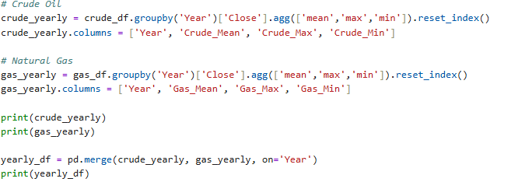

Output:
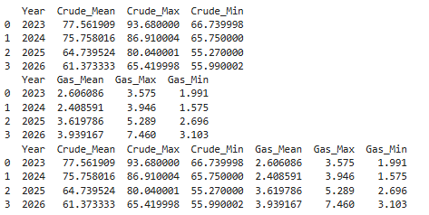

Explanation
Crude Oil
- 2023: Highest average price (~77.6 USD), with max ~93.7 and min ~66.7.
- 2024: Slight decline in average (~75.8 USD).
- 2025: Significant drop in average (~64.7 USD).
- 2026: Lowest average (~61.3 USD), showing a downward trend.
Natural Gas
- 2023: Average ~2.61 USD, relatively stable.
- 2024: Slight decline (~2.41 USD).
- 2025: Sharp increase (~3.62 USD), with max ~5.29.
- 2026: Further rise (~3.94 USD), with max ~7.46, showing volatility.
Combined View
- Crude oil shows a steady decline in average prices from 2023 to 2026.
- Natural gas shows increasing volatility, with averages rising sharply after 2024.
- This contrast highlights different market dynamics in energy commodities.

Moving Average:
Purpose:
To identify short-, medium-, and long-term trends using 20-day, 50-day, and 200-day moving averages.
Definitions:
Moving Average (MA) = Average of closing prices over a specific window of days: 20, 50, 200.
- MA_20 → Short-term trend (20 days)
- MA_50 → Medium-term trend (50 days)
- MA_200 → Long-term trend (200 days)
- Smoothens daily price fluctuations and highlights overall trend.
Crude Oil:
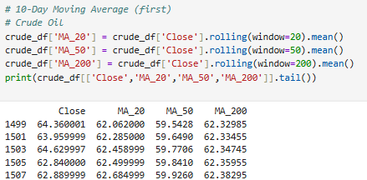

Explanation:
- losing prices are slightly above the 200-day MA, suggesting prices are trading near the long-term trend.
- MA-20 closely follows the closing price, indicating short-term alignment.
- MA-50 remains lower, suggesting weaker medium-term performance.
Natural Gas:
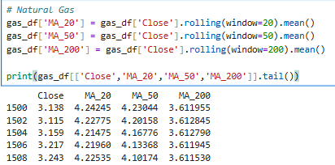
Explanation:
- The closing prices (~3.1–3.2) are below both the 20-day and 50-day averages (~4.1–4.2).
- This indicates that natural gas is currently trading weaker than its short- and medium-term trends.
- However, the 200-day average (~3.61) is closer to the closing price, suggesting long-term stability compared to recent declines.
Matplot:
Crude Oil Moving Averages
Purpose:
Shows short-, medium-, and long-term trends of crude oil prices using 20-, 50-, and 200-day moving averages. Helps visualize trend direction, smooth price fluctuations, and spot potential reversals.
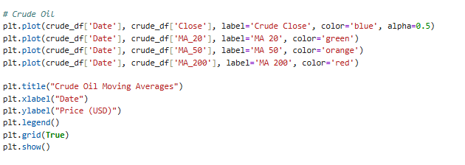
Output:
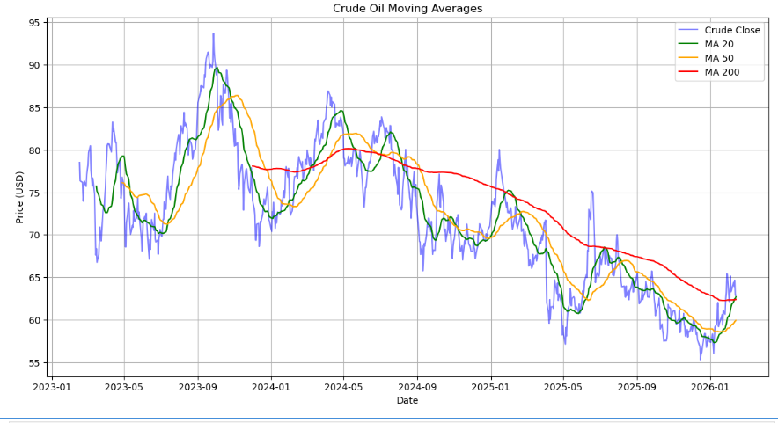

Explanation of Components:
- Blue Line (Crude Close): Represents the actual daily closing price of crude oil.
- Green Line (MA 20): Short-term moving average, reacts quickly to price changes.
- Orange Line (MA 50): Medium-term moving average, smoother, shows sustained trends.
- Red Line (MA 200): Long-term moving average, very stable, used to confirm overall market direction.

Explanation of chart:
- The short-term average (MA 20) closely follows the daily price, highlighting short-term momentum.
- The medium-term average (MA 50) smooths fluctuations, showing broader trends.
- The long-term average (MA 200) acts as a baseline, confirming whether crude oil is in a bullish or bearish phase.

Natural Gas Moving Average:
Purpose:
The purpose of using moving averages is to smooth out price fluctuations and identify the overall trend of natural gas prices. This helps traders and analysts:
- Spot short-term vs. long-term trends.
- Detect potential turning points.
- Make better trading and investment decisions. 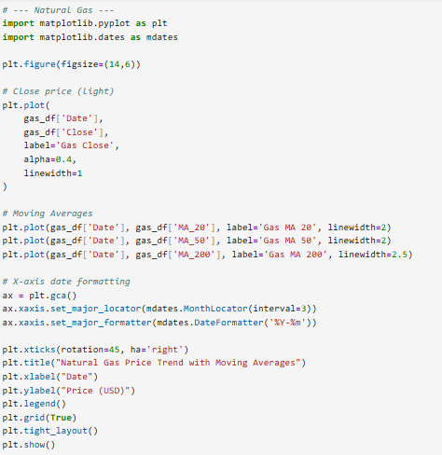

Output:
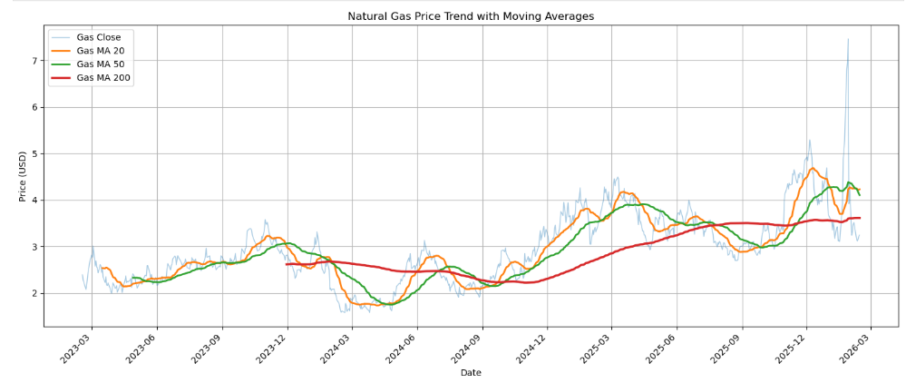
Explanation of Components
- Gas Close (Light Blue Line): Daily closing price of natural gas.
- Gas MA 20 (Orange Line): 20-day moving average, showing short-term trends.
- Gas MA 50 (Green Line): 50-day moving average, showing medium-term trends.
- Gas MA 200 (Red Line): 200-day moving average, showing long-term trends

Observations from the Chart
- Between 2020 and 2023, natural gas prices showed sharp fluctuations.
- Short-term averages (MA 20, MA 50) reacted quickly to price changes.
- Long-term average (MA 200) provided a smoother view of the overall trend.
- Crossovers between these lines highlighted periods of trend shifts.

RSI (Relative Strength Index)
Means:
- RSI = Momentum oscillator measuring the speed and change of price movements.
- Scale: 0–100
  - 70 → Overbought (price very high)
  - <30 → Oversold (price very low)

Purpose:
Measures momentum of crude oil and natural gas prices, highlighting overbought (>70) and oversold (<30) conditions. Helps identify potential trend reversals and support trading decisions.
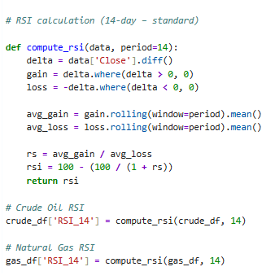
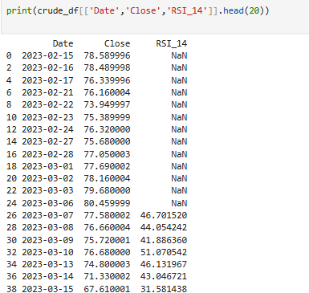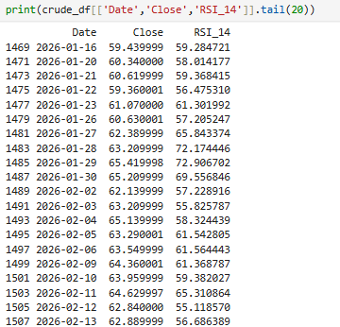

RSI Explanation:
RSI (14-day) was calculated to measure price momentum. Initial values are shown as Nan because RSI requires at least 14 days of data to compute. After that, RSI values
help identify overbought (>70) and oversold (<30) conditions.

Natural Gas - RSI
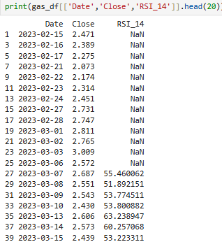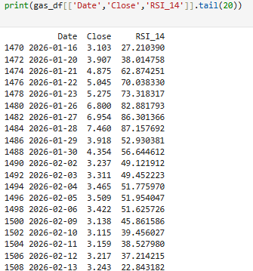

Explanation:
RSI (14-day) was calculated to analyse momentum in natural gas prices. Initial values appear as Nan because RSI requires a minimum of 14 days of data. RSI values above 70 indicate overbought conditions, while values below 30 indicate oversold conditions. In 2026, natural gas showed sharp RSI fluctuations, reflecting high volatility.
  - Example: 2026-01-16 → Close = 3.103, RSI_14 = 27.21 → Oversold
  - Example: 2026-01-28 → Close = 7.460, RSI_14 = 87.16 → Overbought
Matplot:
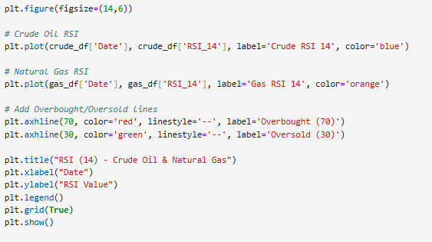

Output:
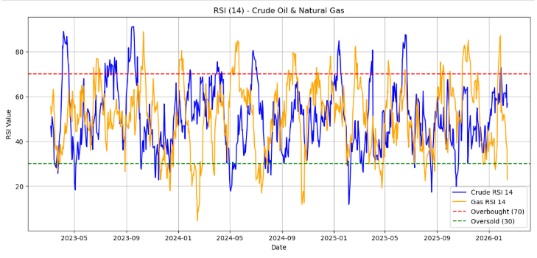
Observations from the Chart
- Both Crude Oil (Blue Line) and Natural Gas (Orange Line) fluctuate between overbought and oversold zones from 2023 to 2026.
- Periods where RSI rises above 70 suggest strong bullish momentum but also risk of correction.
- Periods where RSI falls below 30 suggest bearish momentum but also potential for recovery.
- The chart highlights how momentum shifts differ between crude oil and natural gas, reflecting their unique market drivers (supply, demand, geopolitical factors, weather).

MACD:
Purpose:
MACD shows trend direction and momentum for Crude Oil and Natural Gas. Bullish, Bearish, or Neutral signals help identify trend changes and support trading or forecasting decisions
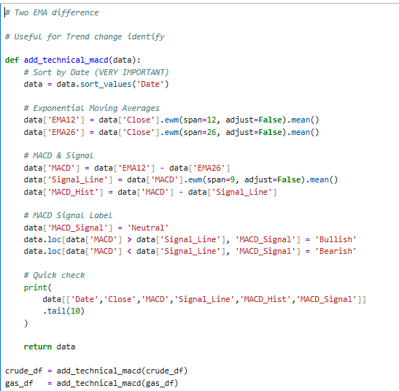

Crude Oil:
Output:
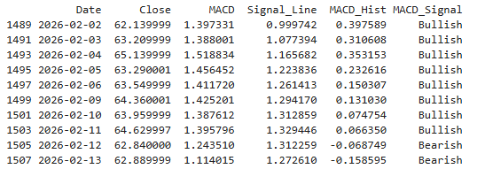
Columns
- Date: Trading day
- Close: Closing price of the commodity on that day
- MACD: Difference between 12-day EMA and 26-day EMA of closing price
- Signal Line: 9-day EMA of MACD
- MACD Hist: MACD – Signal Line; shows momentum strength
- MACD Signal:
  - Bullish: MACD > Signal Line → potential upward trend
  - Bearish: MACD < Signal Line → potential downward trend
  - Neutral: MACD ≈ Signal Line → trend unclear
Explanation:
- Bullish signals (Crude Oil, e.g., 2026-02-02 to 2026-02-11): Prices likely trending upward; MACD above Signal Line; histogram positive.
- Bearish signals (Crude Oil, 2026-02-12 onwards & Natural Gas 2026-02-02 onwards): Prices likely trending downward; MACD below Signal Line; histogram negative.
- Histogram magnitude: Shows momentum strength; higher positive → strong uptrend, higher negative → strong downtrend.
- Trend Reversal Identification: When MACD crosses Signal Line from below → potential bullish reversal; from above → bearish reversal.

Natural Gas:
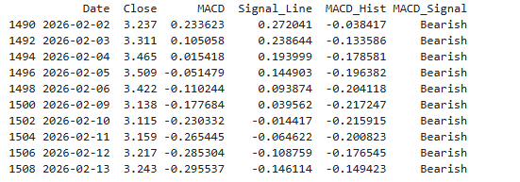

Explanation:
- 2026-02-02 to 2026-02-13: All entries show Bearish
- MACD < Signal Line
- Histogram negative
- Prices trend downward or weak momentum (3.237 → 3.243, small fluctuations)
- Histogram magnitude: Indicates momentum strength
- More negative → stronger downward trend
- Less negative → weak downward momentum
- Trend Reversal: If MACD crosses above Signal Line → bullish trend possible in future
Matplot:
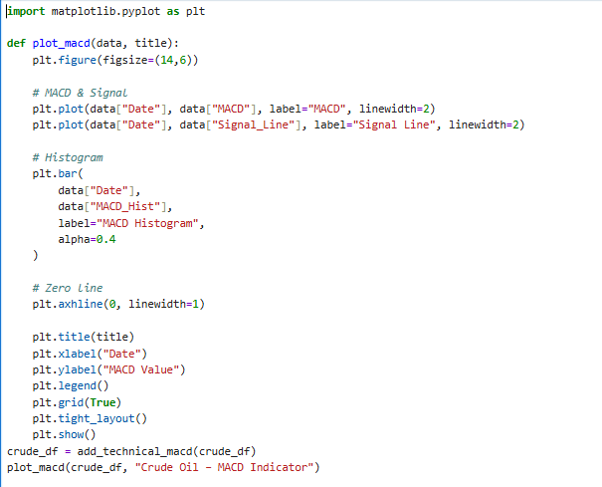
Output:
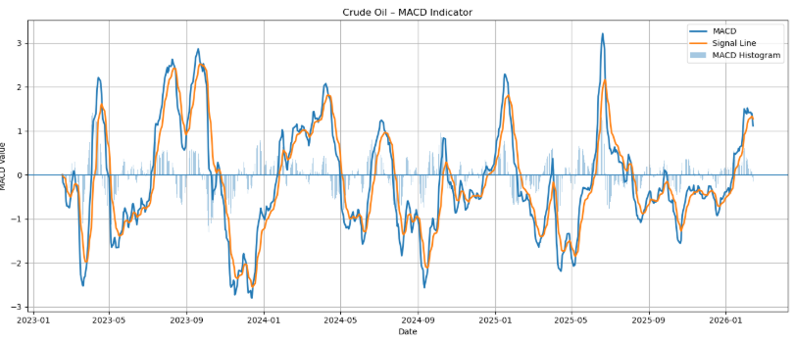

Explanation of Components
- MACD Line (Blue): Calculated as the difference between the 12-day and 26-day exponential moving averages (EMA). Shows short-term momentum.
- Signal Line (Orange): A 9-day EMA of the MACD line. Acts as a trigger for buy/sell signals.
- MACD Histogram (Light Blue Bars): Represents the difference between the MACD line and the Signal line. Positive bars indicate bullish momentum; negative bars indicate bearish momentum.

Observations from the Chart
- Between 2023 and 2026, multiple crossovers occur, marking shifts in crude oil momentum.
- Periods where the MACD line rises above the Signal line align with bullish phases in oil prices.
- Periods where the MACD line falls below the Signal line align with bearish corrections.
- The histogram provides a quick visual of momentum strength, with spikes showing strong moves.

MACD -Natural gas
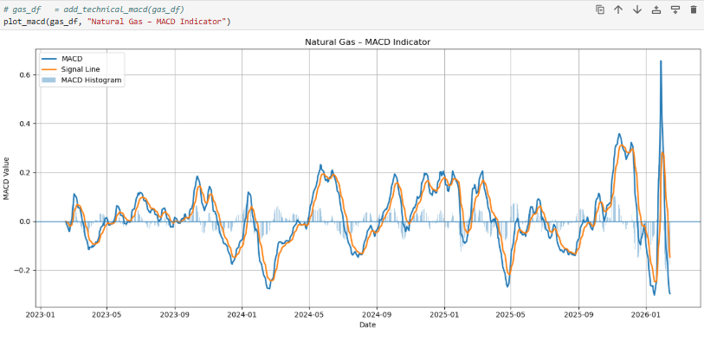

Explanation of Components
- MACD Line (Blue): Difference between the 12-day EMA and 26-day EMA. Shows short-term momentum.
- Signal Line (Orange): A 9-day EMA of the MACD line. Acts as a trigger for buy/sell signals.
- Histogram (Light Blue Bars): Difference between MACD and Signal line. Positive bars = bullish momentum; negative bars = bearish momentum

Observations from the Chart
- Between 2023 and 2026, multiple crossovers occur, marking shifts in natural gas momentum.
- Bullish phases appear when the MACD line rises above the Signal line.
- Bearish phases appear when the MACD line falls below the Signal line.
- The histogram highlights the strength of these moves, with spikes showing strong momentum shifts.
Yearly Trend
Purpose
- Yearly Trend Summary: Shows how many days each year were trending up, down, or sideways.
- Trend Analysis: Helps identify years dominated by bullish or bearish trends.
- Visual & Report Support: Useful for dashboards, charts, and annual market behaviour analysis.
- Decision Support: Traders or analysts can see which years had sustained trends, helping in strategy planning.
- Year: Trading year
- Downtrend (%): % of days price was below MA_20 → bearish trend
- Uptrend (%): % of days price was above MA_20 → bullish trend
- Sideways (%): % of days price was near MA_20 → neutral/consolidation
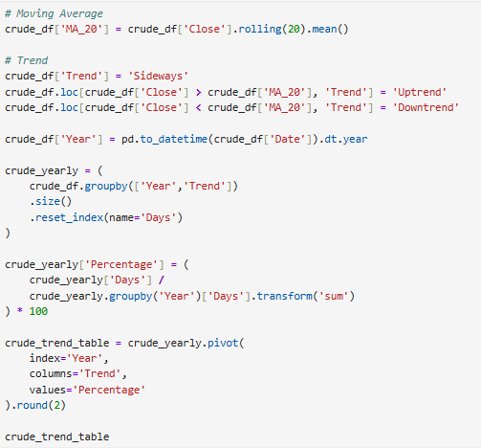
Output:
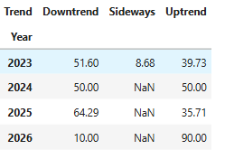
- 2023: 51.60% Downtrend, 39.73% Uptrend, 8.68% Sideways → Slightly bearish year with some bullish periods
- 2024: 50% Uptrend, 50% Downtrend, 0% Sideways → Balanced trend year
- 2025: 64.29% Downtrend, 35.71% Uptrend → Mostly bearish year
- 2026: 90% Uptrend, 10% Downtrend → Strong bullish trend so far

Natural Gas trend:
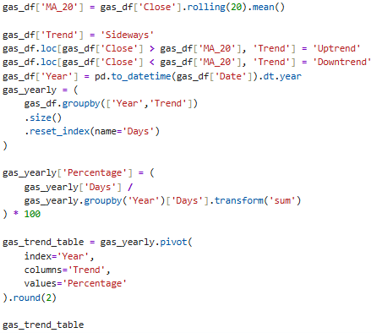
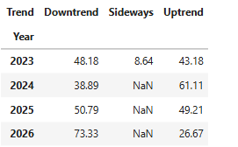
Explanation:
- 2023: 48.18% Downtrend, 43.18% Uptrend, 8.64% Sideways → Slightly bearish year
- 2024: 38.89% Downtrend, 61.11% Uptrend → Mostly bullish year
- 2025: 50.79% Downtrend, 49.21% Uptrend → Almost balanced year
- 2026: 73.33% Downtrend, 26.67% Uptrend → Strong bearish trend so far

Volatility Pattern (High – Low Range):
  - High Volatility: Day range > average range → price fluctuated more than usual
  - Low Volatility: Day range ≤ average range → price relatively stable
Purpose
- Identify Price Fluctuations: Highlights which days had unusually large or small price movements.
- Support Risk Analysis: High volatility days indicate higher risk, Low volatility indicates stability.
- Trend & Market Behaviour: Helps understand market momentum and periods of high uncertainty.
- Dashboard & Reporting: Useful for plotting volatility patterns and analysing commodity behaviour visually.

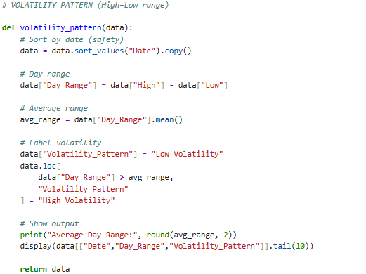

Crude Oil Output:
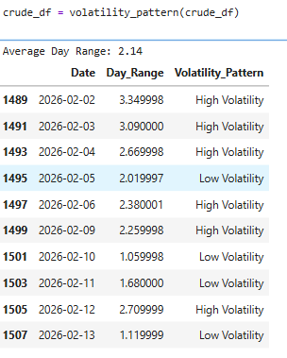
Explanation:
- Crude oil experienced frequent high volatility days (Feb 2–4, Feb 6, Feb 12).
- Low volatility days (Feb 5, Feb 10–11, Feb 13) show smaller price movements.
- This mix indicates alternating periods of stability and sharp fluctuations.
Business Relevance
- Traders use volatility patterns to adjust risk exposure.
- High volatility days → higher risk but also higher profit opportunities.
- Low volatility days → safer but limited trading opportunities.
Natural gas
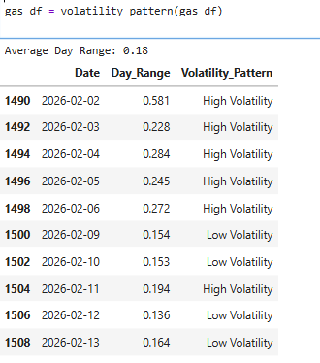
Explanation
- 2026-02-02 to 2026-02-06: High Volatility (0.228 – 0.581) → big price swings, risky or active market
- 2026-02-09 to 2026-02-13: Mostly Low Volatility (0.136 – 0.164) → stable prices, low fluctuations
- 2026-02-11: High Volatility (0.194) → one-off spike above average
- High Volatility Days: Market was highly active; traders may experience larger profits or losses.
- Low Volatility Days: Market stable; fewer opportunities for quick trading.

Golden Cross & Death Cross:
Purpose
1. Identify Trend Reversals: Helps detect major trend shifts in the market.
2. Long-term Market Analysis: Useful for assessing bullish or bearish cycles over months or years.
3.Trading Signals: Traders use Golden Cross for entry (buy) and Death Cross for exit (sell).
4. Visualization & Reporting: Supports plotting trend shifts and highlighting key market signals.
1.Calculates two moving averages:
- MA_50: 50-day moving average
- MA_200: 200-day moving average
2.Detects crossover signals:
- Golden Cross: MA_50 crosses above MA_200 → potential long-term bullish trend
- Death Cross: MA_50 crosses below MA_200 → potential long-term bearish trend
3.Labels each crossover day in Cross Signal column
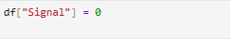
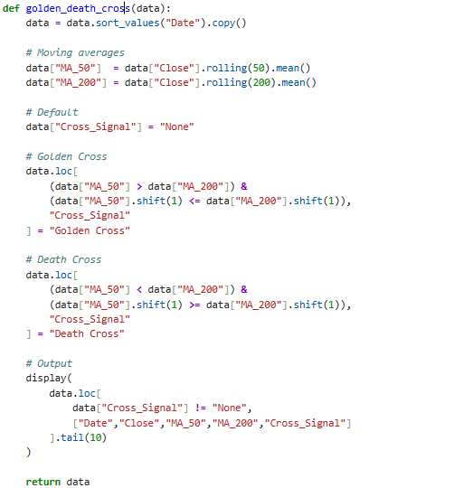

Output:
Crude – Golden Death Cross
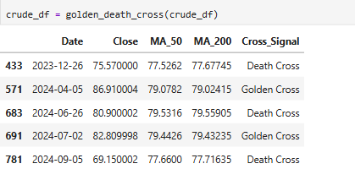
Explanation:
- On 2023-12-26, a Death Cross indicated weakness in crude oil prices.
- On 2024-04-05, a Golden Cross suggested a bullish recovery.
- The alternating signals in 2024 (April, June, July, September) show volatile market conditions with frequent trend reversals.
Business Relevance
- Traders use Golden/Death Cross signals to time entry and exit points.
- Investors view Golden Crosses as long-term bullish confirmation, while Death Crosses warn of extended declines.
- Frequent crossovers in 2024 highlight crude oil’s instability, making risk management essential.

Natural Gas – Golden Death Cross:
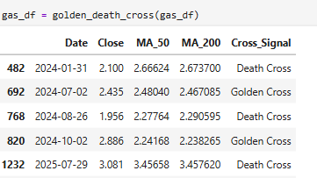
Explanation
- On 2024-01-31, a Death Cross indicated weakness in natural gas prices.
- On 2024-07-02, a Golden Cross suggested recovery.
- On 2024-08-26, another Death Cross showed renewed weakness.
- On 2024-10-22, a Golden Cross signalled bullish momentum.
- By 2025-07-29, a Death Cross again marked a bearish decline.

Matplot:
Purpose
- Visual Trend Analysis: Quickly shows where bullish (Golden Cross) and bearish (Death Cross) trends start.
- Market Timing Support: Traders can see potential entry (Golden) and exit (Death) points.
- Comparison with Price: Helps understand how price reacts after crossovers.
- Report & Dashboard: Makes it easy to include in presentations or Word documents for clear trend illustration.
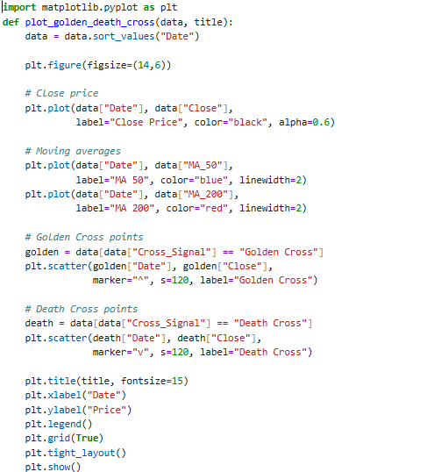
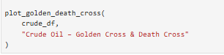

Output:
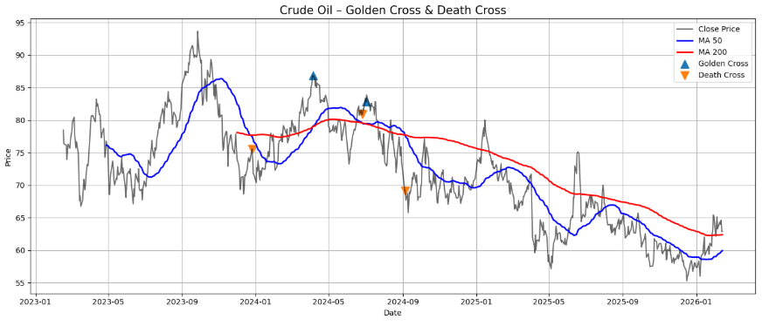

Lines on the Chart:
- Black Line (Close Price): This shows the actual daily closing price of crude oil over time.
- Blue Line (MA 50): This is the 50-day moving average — it smooths out short-term price fluctuations and shows the short-term trend.
- Red Line (MA 200): This is the 200-day moving average — it reflects the long-term trend of the market.
Golden Cross (Blue Up Arrow):
- A bullish signal.
- Happens when the 50-day MA crosses above the 200-day MA.
- Indicates a potential upward trend or rally in prices.
- In the chart, this occurred around early 2024, followed by a price increase — confirming the bullish momentum.
Death Cross (Orange Down Arrow):
- A bearish signal.
- Happens when the 50-day MA crosses below the 200-day MA.
- Suggests a possible downward trend or market weakness.
- This appears around mid-to-late 2025 in the chart, followed by a decline in crude oil prices.

Business Impact
- Golden Cross: “Crude oil entered a bullish phase, indicating potential opportunities for energy sector growth.

- Death Cross: “Market sentiment turned bearish, signalling risks for investors and downstream industries.

Natural Gas
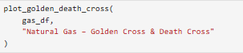
Output:
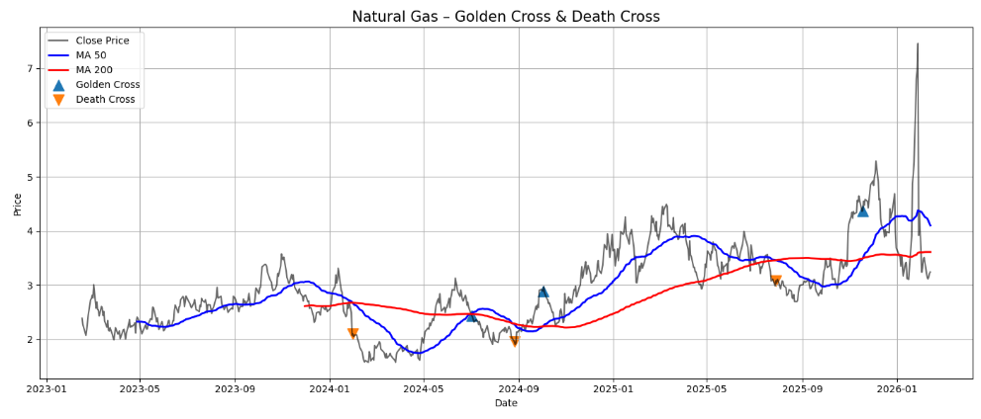
Explanation of Indicators
- 50-Day Moving Average (MA 50 – Blue Line): Short-term trend indicator.
- 200-Day Moving Average (MA 200 – Red Line): Long-term trend indicator.
- Close Price (Black Line): Actual daily market price of natural gas.

Golden Cross (Blue Upward Triangle)
- Occurs when MA 50 crosses above MA 200.
- Suggests bullish momentum and potential price increases.
- Often interpreted as a buy signal.
Death Cross (Orange Downward Triangle)
- Occurs when MA 50 crosses below MA 200.
- Suggests bearish momentum and potential price declines.
- Often interpreted as a sell signal or cautionary sign.
Observations from the Chart
- Several Golden Crosses and Death Crosses appear between 2023 and 2026.
- Each crossover marks a possible trend reversal in natural gas prices.
- A sharp spike in late 2025 shows how external factors (supply, demand, geopolitical events) can cause sudden price movements, even beyond technical signals.
- Golden Crosses align with upward phases, while Death Crosses align with downward corrections.

MYSQL
INSTALL MYSQL CONNECTOR

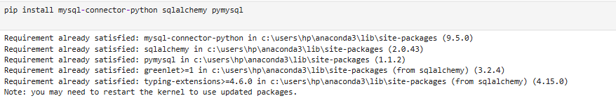

Connect to MySQL
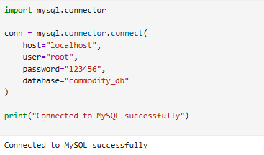
LOAD DATA:
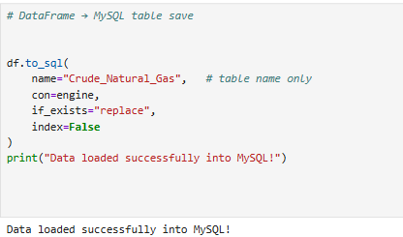

Create Engine:
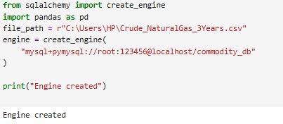

Check first 5 Rows from MySQL Table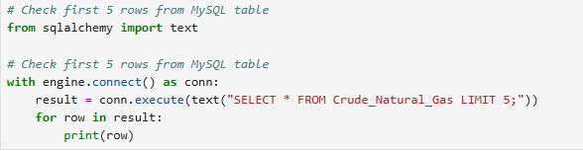
SQL Query:
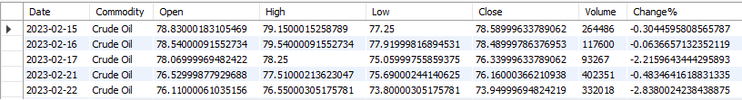
Crude Oil & Natural Gas
Daily High-Low range:
Purpose
- Track Daily Price Movement: Understand how each commodity moved day-to-day.
- Analyse Volatility: Daily High-Low range shows intra-day swings.
- Performance Metrics: Daily % change helps compare relative price movement.
- Historical Analysis: Last 3 years’ data is useful for trends, seasonality, and reporting

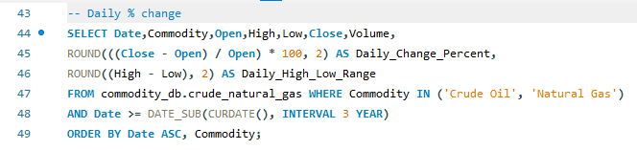

Output:

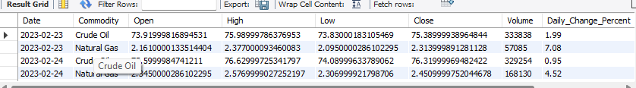

Explanation
This query retrieves daily Open, High, Low, Close, and Volume for Crude Oil and Natural Gas over the last 3 years, along with daily % change and intra-day High-Low range for volatility and performance analysis.

Highest Close:
Purpose
- Identify Peak Prices: Shows the maximum closing price for each commodity.
- Historical Analysis: Helps compare peak values of Crude Oil vs Natural Gas.
- Trading Insight: Traders and analysts can benchmark highest historical prices for strategy and reporting.

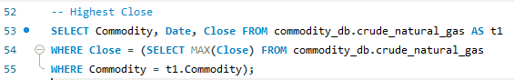
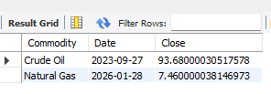
Explanation:
This table summarizes the highest closing price for Crude Oil and Natural Gas, helping to identify historical peak values for market analysis and trading insights.

Lowest Close
Purpose
- Identify Minimum Prices: Shows the minimum closing price for each commodity.
- Historical Analysis: Helps compare lowest values of Crude Oil vs Natural Gas.
- Trading Insight: Useful for benchmarking historical lows for strategy, risk management, and reporting.

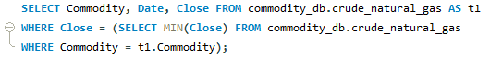

Output:
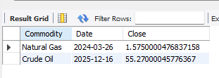

Explanation
This query retrieves the lowest closing price and its date for each commodity, supporting historical low analysis and market comparison.

Yearly Summary:
Purpose
- Yearly Performance: Understand average price levels and trends year by year.
- Volatility Analysis: Shows which years had higher price fluctuations.
- Historical Peaks & Lows: Max/Min Close helps identify yearly extremes.
- Decision Support: Useful for analysts and traders for trend evaluation, reporting, and strategy planning.

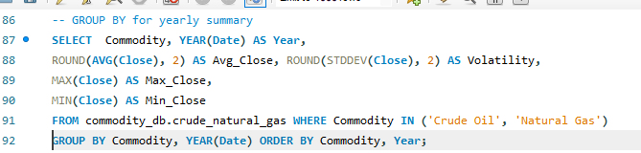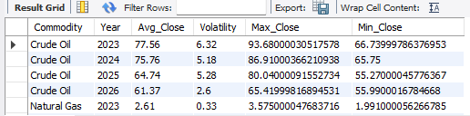

Explanation:
This query summarizes yearly performance for Crude Oil and Natural Gas, showing average, volatility, maximum, and minimum closing prices for historical trend and risk analysis.

Compare Crude vs Gas:
Purpose:
- Daily Price Comparison: Shows day-by-day relative performance between Crude Oil and Natural Gas.
- Market Insight: Helps identify correlations, gaps, or divergences in daily closing prices.
- Analysis & Reporting: Useful for traders and analysts to compare commodity behaviour in the same period.
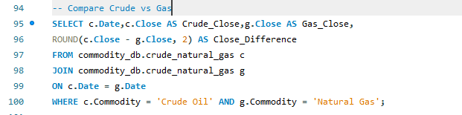

Output:
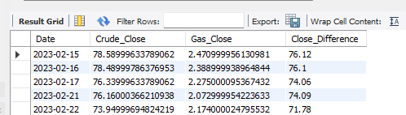

Explanation
This query compares daily closing prices of Crude Oil and Natural Gas, including the absolute difference, to analyse relative performance and market correlation.

POWERBI
Purpose:
The purpose of this dashboard is to provide a comprehensive analysis of crude oil and natural gas prices. It enables users to track market movements, compare historical highs and lows, monitor volatility, and identify long-term trends. This supports business decision-making, investment strategies, and risk management in the energy sector.
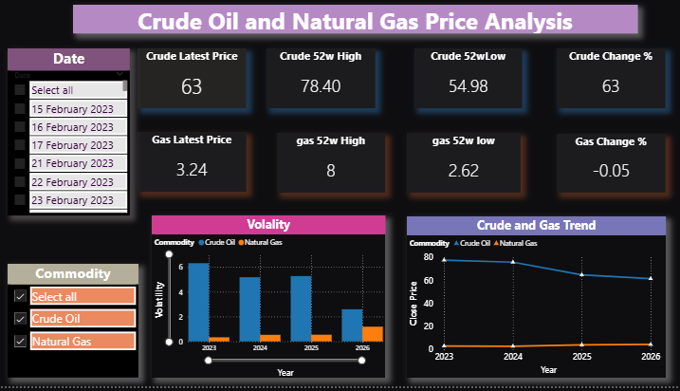
Dashboard Components:
Date Selector:
Allows filtering by specific dates, enabling time-based comparisons.
Commodity Selector:
Let the user choose between crude oil and natural gas, or view both together.
Latest Price:
Displays the current market price of each commodity, useful for tracking immediate value.
- DAX Function:
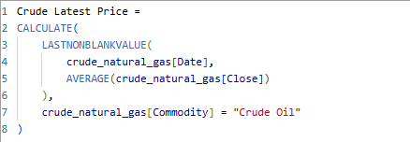
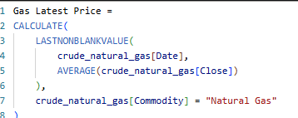

52-Week High/Low:
Shows the highest and lowest prices in the past year, helping identify trading ranges and market extremes.
Dax Function:
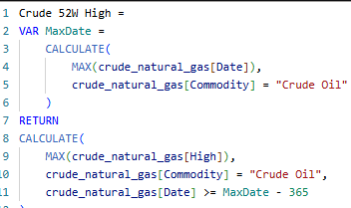

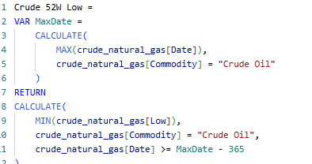
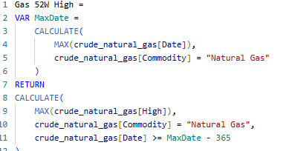
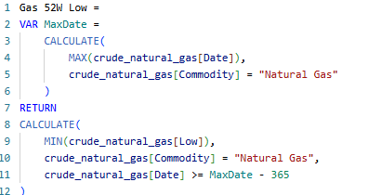

Change Percentage:
Highlights short-term momentum, showing whether prices are rising or falling.
Dax Function:
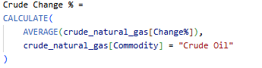
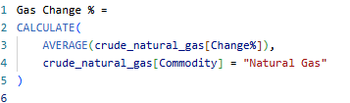

Volatility Chart:
Presents yearly volatility levels, which are critical for assessing risk and uncertainty in commodity markets.
Dax Function:
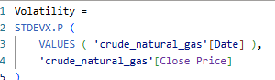
Trend Line Chart:
Illustrates long-term price movements, revealing whether the market is in decline, growth, or stability.
Insights
- Crude Oil: Shows moderate decline over years, with higher volatility in 2024–2025.
- Natural Gas: Displays sharper decline, with volatility spikes in 2023 and 2025.
- Comparison: Crude oil is relatively more stable than natural gas, but both show downward trends.

Technical Indicators:
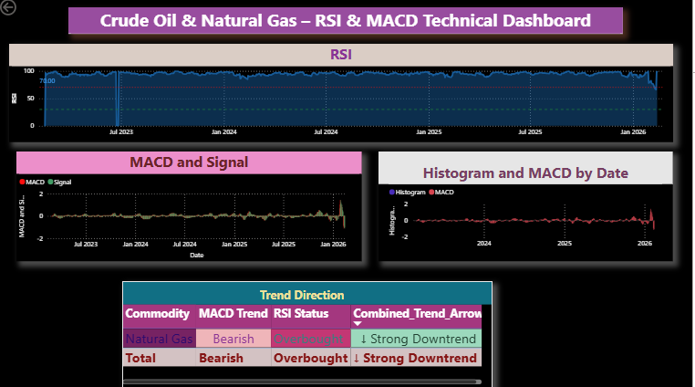

RSI (Relative Strength Index)
- Purpose: Measures momentum — how fast and strong price movements are.
- Scale: 0 to 100.
  - Above 70: Overbought → price may be too high, possible reversal or pullback.
  - Below 30: Oversold → price may be too low, potential bounce or recovery.

DAX Function:
AVG Gain AVG Loss
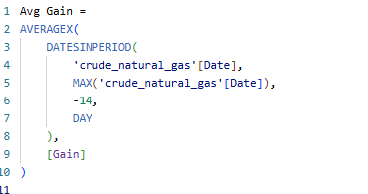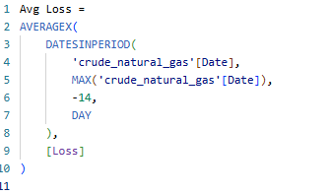

RSI:
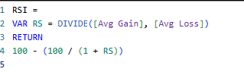

RSI Status:
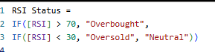

MACD (Moving Average Convergence Divergence)
- Purpose: Detects trend direction and momentum shifts.
- Components:
  - MACD Line: Difference between 12-day and 26-day EMAs.
  - Signal Line: 9-day EMA of the MACD line.
  - Histogram: Visual difference between MACD and Signal — shows strength of momentum.

DAX Function:
EMA12 EMA26
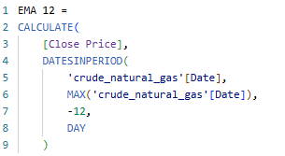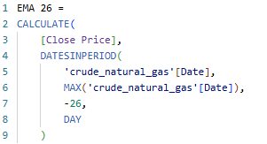

MACD
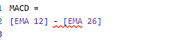
Signals:
  - MACD crosses above Signal: Bullish momentum.
  - MACD crosses below Signal: Bearish momentum.

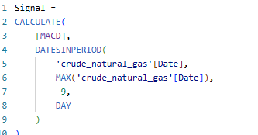

MACD Trend
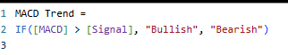

Drill Through- Indicators – Crude Oil
The Drill Through feature in the dashboard allows users to move from a summary view into a detailed analysis page. This enhances interactivity and provides deeper insights into specific commodities and time periods
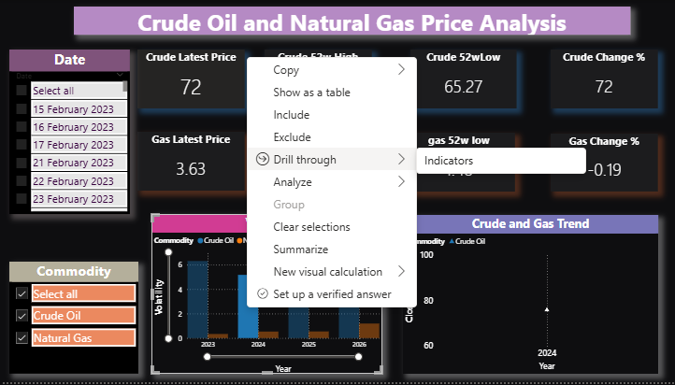
When a user selects Crude Oil volatility from the bar chart (for example, the year 2024) and applies the Drill Through → Indicators option, the dashboard opens a dedicated page showing detailed indicators for Crude Oil.
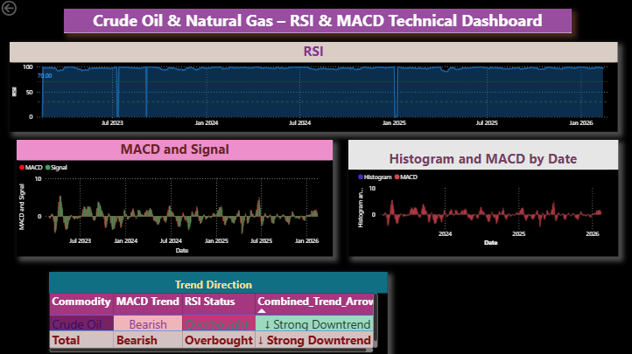

RSI Chart (Top)
- RSI values fluctuate over time. For crude oil, RSI is currently above 70, signalling an overbought condition — a potential warning for a price pullback
.
MACD and Signal Chart (Bottom Left)”
- Crude oil’s MACD is below the signal line, indicating bearish momentum.

Histogram:
- Histogram bars are mostly negative, confirming weakening momentum in crude oil.
Trend Direction Table (Bottom Centre)
- Commodity: Crude Oil
- MACD Trend: Bearish
- RSI Status: Overbought
- Combined Trend Arrow: ↓ Strong Downtrend
This means although the price is high (overbought), momentum is turning negative — a strong signal for a potential price reversal or correction.
Drill Through Indicators – Natural Gas (2026)

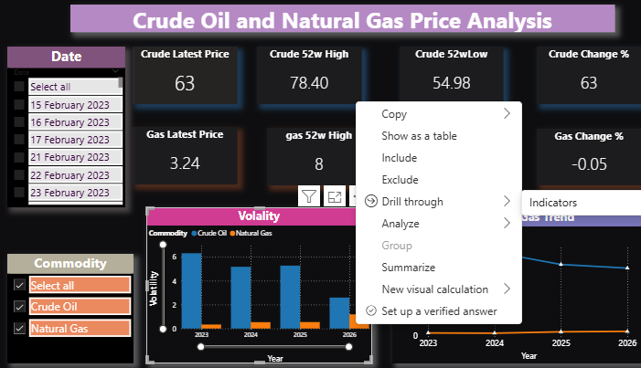

Explanation:
This Drill Through page provides a detailed technical and trend analysis of Natural Gas for the year 2026. While the main dashboard shows overall price and volatility, this page focuses on specific indicators and signals to understand market behaviour in depth.
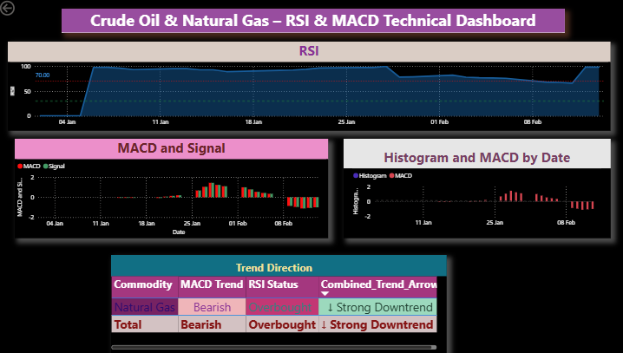
Key Indicators
- Relative Strength Index (RSI)
- RSI crossed above 70 in early February, signalling overbought conditions for natural gas.
- MACD (Moving Average Convergence Divergence)
  - Compares short-term and long-term moving averages.
  - Current MACD trend is bearish, signalling downward momentum.
  - Crossovers between MACD and the signal line confirm sell signals.
- Histogram
  - Shows the difference between MACD and the signal line.
  - Red bars below zero highlight negative momentum, reinforcing the bearish outlook.
- Trend Direction Summary
  - Commodity: Natural Gas
  - MACD Trend: Bearish
- RSI Status: Overbought

- Combined Trend: ↓ Strong Downtrend
This combination suggests that although prices are high (overbought), momentum is turning negative — a strong warning for a potential price drop.

Business Impact
- Traders: Entry/Exit timing
- Investors: Risk assessment
- Energy Companies: Price forecasting
- Policy Makers: Supply-demand planning.

Conclusion
This project successfully demonstrates how data analytics combined with technical indicators and global news events can explain price movements in energy commodities.
- Crude oil is highly sensitive to geopolitical and macroeconomic events
- Natural gas is generally stable but prone to sudden spikes
- Technical indicators (RSI, MACD, MA) effectively identify risk and trend reversals
Overall, the project highlights the importance of data-driven decision-making in energy markets and showcases strong analytical and business interpretation skills.

Future Scope:
- Price Forecasting using Machine Learning.
- Real-Time Market Data Integration.
- News & Sentiment Analysis (NLP)
- Advanced Risk Metrics (Va R, CVaR, Drawdown)
- Multi-Commodity Expansion
- Automated Trading Strategy & Back testing.
- Cloud & Big Data Integration
- Advanced Power BI Enhancements
- AI-Driven Market Intelligence System

